- Tim’s favorite rides is Ferris Wheel. He rode 6 different Ferris Wheels in 2018, also he rode 6 different Ferris Wheels in 2019. How many Ferris Wheels did he rides? (Students please write the solution on the empty space)

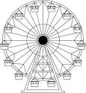

- A company built 5 Ferris Wheels in March and built 6 Ferris Wheels in September. How many Ferris Wheels did the company built? (Students please write the solution on the empty space)

